**OUR CANYON**

**A story of fishing, friendship, and faith**

**Growing up in Idaho (and Utah which is unfortunate for Brad) we are born and raised with an overwhelming sense of the outdoors and activities experienced during different seasons. One of the best times of year is Memorial Day weekend for many reasons. It is the “official” start to summer and as any fisherman know it is always opening day of fishing season. For me this used to mean I would get to go dunk a worm below American Falls reservoir with the Old Man. However, as I would later be taught in life by my friend Dan, the only real way to fish is with a fly rod and a hopper dropper combo. “Dunking a worm is for amateurs” I was told. What he didn’t tell me is how expensive the sport could be. Worms were a dollar a dozen. Flies range from one to five dollars each and you have to have many sizes and varieties in order to be effective at catching. As we all know there are plenty of people that can fish but only a select few become Catchers. Enter my buddy Brad Chatlin. The guy can catch a fish in a mud puddle. If you don’t believe me just ask him.**

**Brad and I had fished together a few times at the Owyhee River in Oregon. On our trips to Oregon he would tell me about his favorite fishing place on the planet and swore me to secrecy before giving me too many details. He spoke of a place so entwined by the beauties and forces of nature that pictures and words would not do it justice. He would have to take me so I could see for myself. The place he was so passionate about is the south fork of the Boise River in the canyon section. Sorry Brad, the secret is out now. He told stories of starving fish so excited to see the opportunity of food that even a novice like myself could surely at least catch one fish. So being the studious fisherman I was I agreed to allow him to take me to this area of heaven on earth so that I could finally catch a fish.**

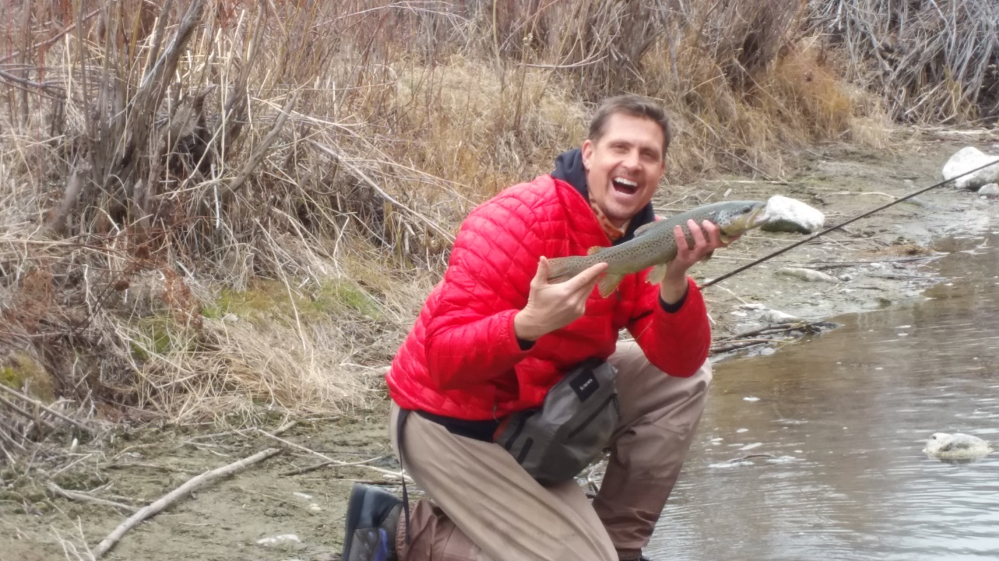

**While he was right about the serene setting and natural awe of the canyon, he forgot to mention that you should be a level 5 pontoon operator (or whatever a professional rafter is called) in order to try to navigate through portions of this river. On top of that you would be fishing at the same time. Sounds fun right??? Not so for my first time down the river. However, after a couple of years working the canyon section with him and other friends, I got to a comfort level where I felt I could handle most of the river like a seasoned pro. As this story unfolds you will see that even the more proficient outdoorsman is no match for Mother Nature if you do not give her the respect she demands.**

**It was Memorial weekend 2016 and we had been planning a trip down the river on the Tuesday following Memorial Day. The reason this day was chosen is because there would be less people on the river as most of America would be back at work. Lucky for me I was traveling with a doctor who could get a day off in the middle of the week. The “doctor” part will come into play later. The trip was originally scheduled with five of us going together. However, as we got closer to the departure date the numbers began to dwindle. On Monday evening it was down to just Brad and I. In some ways less is more but in our case it is often better to have a voice of reason along for the ride. We have a tendency to think we are invincible when it comes to our skills. We blame Tad for bailing on us and leaving us without a voice of reason for the trip. Tad said he was just too busy but we all know he just can’t catch as many fish and has a hard time hearing the repetitive roar of Brad saying “YES! Another one and this is a hog. I caught him on top this time!”**

**What I didn’t tell anybody until after the trip is that as Monday evening rolled around I began to get an uneasy feeling about the trip ahead. I didn’t say anything because I knew this was like heroin for my friend and he desperately needed a fix. Who was I to bail at the last minute because I was worried about some stupid rapids? At least that is the excuse I kept giving myself. I had wrapped up all of my work over the long weekend and had no reason not to go. Even with the uneasy feeling in my head or gut (wasn’t sure which at the time) I began packing for the 17 mile stretch of river with no roads, steep canyon walls, and more fish than Fred Meyer meat department. As I was loading my pack with the essentials like flies, tippet, leaders, extra real, extra rod , ect. I came across a Leatherman that my wife gave me years ago. I said to myself “self, you should throw this in your pack. You never know when you will need it.” So in it went with the extra dry clothes I always pack in case my great skills end up getting me wet.**

**Even with the awesome tools I was bringing along this time, I couldn’t shake the feeling that something about this trip was going to be different. Growing up in spiritual family, we were always taught to listen close to these feelings as it is very likely God may be trying to tell you something. However, I figured that wasn’t the case and I was just being a wuss knowing the flows were higher than normal. High flows can sometimes make rafting easier as most of the rocks have enough water flowing over them that there are less obstacles to maneuver around. However, it can also change a river from something you are very familiar with to something you have never seen before. Me being smarter than a higher power in this particular circumstance would prove to make for a very long day and a painfully needed reminder that I am not in charge.**

**After a good night sleep I woke up in the morning with no negative feelings about the trip. Brad would be over in a few minutes to pick me up and the excitement of our adventure was beginning to build. I was definitely going to catch more fish than him this time. There was no doubt.** 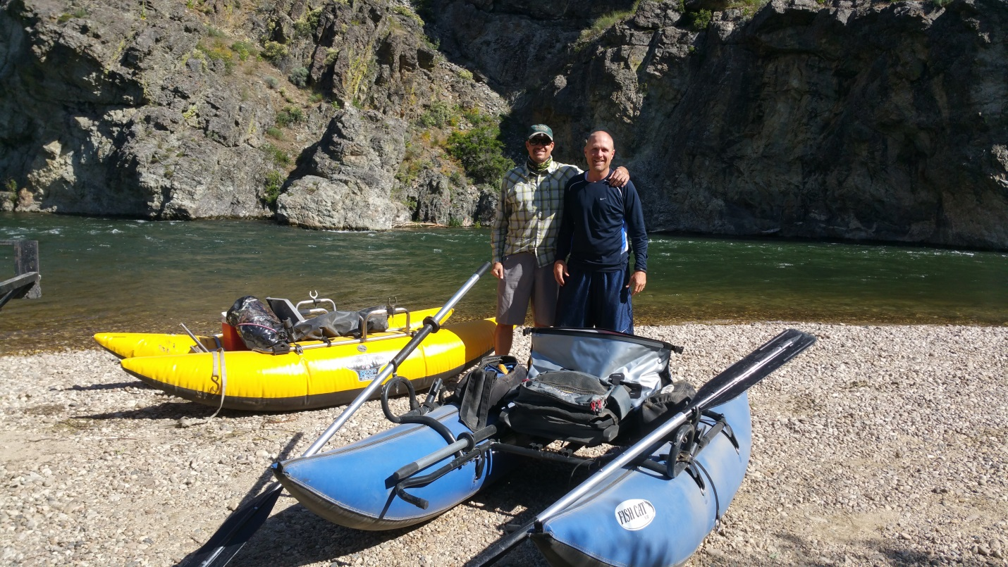

**The day started perfect. The weather was great, the water was clear, and wildlife was abundant. What a day we were going to have. Even though we didn’t get coverage on the river, I decided to bring my phone on the boat to document the trip. I would end up taking at least one picture of a fish I caught (the only fish) and a few pictures of Brad screaming “Oh Ya. That’s number six. How are you doing down there?”**

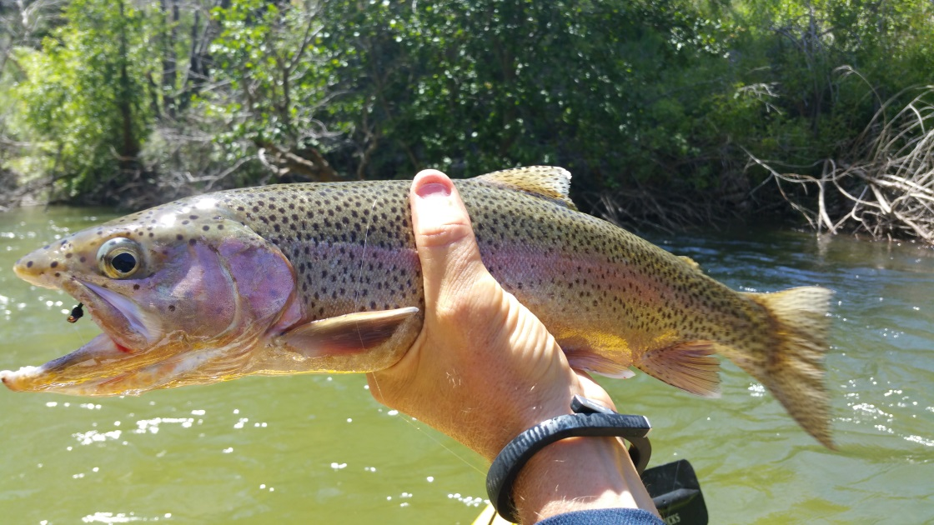

**I was able to successfully photograph a pair of bald eagles fishing within 20 yards of me. It truly is a magnificent place. For being so close to civilization, we were still so far away. I always take a minute to appreciate the beauty of the situation I am in and how fortunate I am to be able to enjoy such pleasures.**

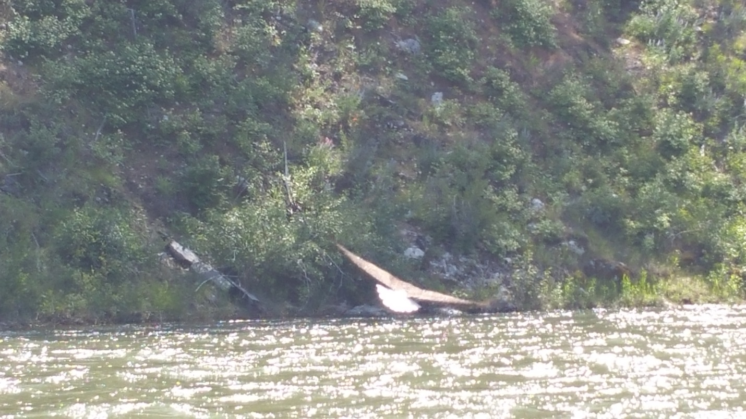

**Throughout the 17 mile trip there are many places to stop and enjoy or try to grasp how nature could shape such a canyon. We thought we had a good grasp on this concept but were about to learn how truly awesome nature can be. There are multiple sections of rapids in the river that can quickly remind you how insignificant and small we really are.**

**The first test of rowing skills would be just around the corner at a section called Raspberry rapids. Although we have both made this passage many times it is always a little nerve racking approaching the first of two major sections. It is customary for us to stop above these rapids and walk to the edge to plan a route down the particular section. However, upon arriving at Raspberry, we elected just to continue on. This was uneventful as we both made it without a hitch. I was beginning to get a little too big for my britches as I just navigated a possible class three rapid without breaking a sweat. I thought to myself “I just tore that rapid a new A-hole. Bring it on.”**

**Raspberry marks a section in the river that lets you know you are now in the canyon. Meaning both sides of the river are surrounded by towering cliffs and no real pull outs. This is part of what makes the canyon section so intriguing. The lack of access and remote location makes one feel as though they are the only person on the planet. It just so happens, we were told by our shuttle driver (she shuttles our vehicle to the bottom of the river so we don’t have to go back and fetch it) that we were the only people on the river that day. That is what we get for going on the Tuesday after Memorial Day.**

**This fact is what makes the rest of the story such a scary event.**

**We began to approach a new rapid that was formed a couple of years ago from a major mud slide between some of the cliffs. Rocks , earth, and debris slid into the river in such an amount it created a small dam with a large new rapid. Some say it is a class five at certain water levels. However, I am a mere bait fisherman so what would I know? This area is named Buffalo Run after Buffalo creek which is where the run off came from. As with the other rapids, both Brad and I have taken these very same boats down this rapid a few different times. However, this was a water level that added a special fear factor to it. We both had nerves and we both thought we knew the dangers we would face by trying to “shoot” this section. We beached our single man pontoon boats at the top of the section in order to map out our route through what would become our nightmare and spiritual revival. As is customary with men when beaching pontoon boats, we took off our life jackets in order to De-brief and use the “facilities”. After taking care of business we approached the side of the river and noticed a significant change in what we remembered. The water level had created a so-called vortex in the middle of the river. We both knew that anything ending up in this area would surely flip or tip over.**

**Brad asked me while looking at this area “At what point are we being wussies or is it just too dangerous”? He must not know that I totally just kicked Raspberry’s butt. Of course we could take this one. My reply was “No way am I going first. You have way more experience. However, it will be a freakin sweet ride. I will totally film you going down and if you make it I will follow.” I mean what are friends for right??**

**I don’t know what pushed him over the edge but he decided to go for it. This is where we really missed our friend Tad and the voice of reason he always brings on these trips. As Brad put his life jacket back on and began to ready his boat, I pulled my phone from the dry bag and made ready to film this epic triumph.**

**He started down the rapid and was looking like a seasoned pro. He handled the drop in and hit his line perfect. The boat was facing forward and he proceeded into what would become his demon. The water was roaring so load it was absolutely impossible to hear any verbal response or communication. I saw his boat headed straight for the vortex. I could only hope at this point his comment of “what is the worst that could happen, We get wet?” would be our outcome. As his boat hit the vortex I knew it was inevitable he was going over. There was so much water moving so fast. There were no other options.**

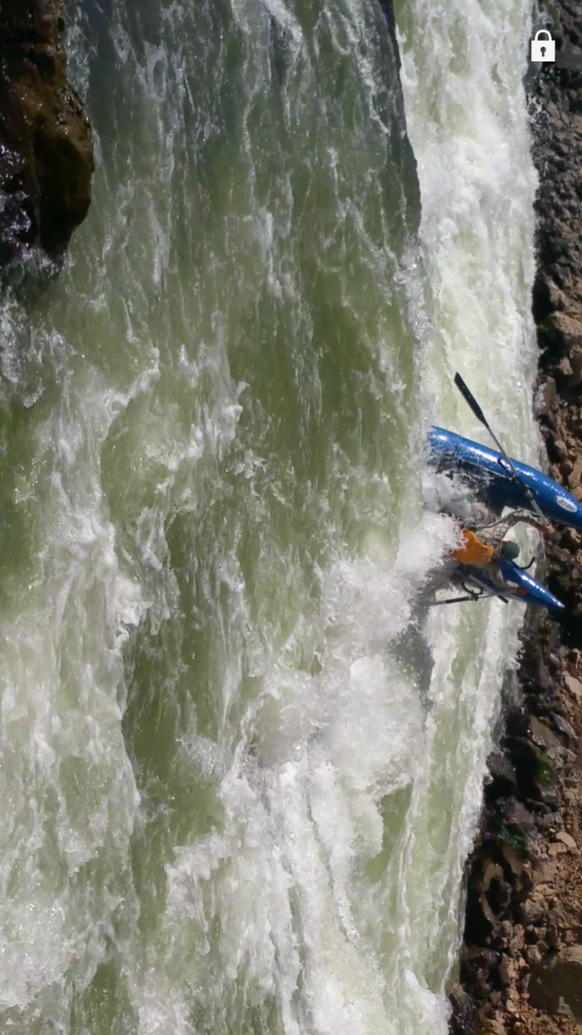

**As he flipped I had a moment of panic but he immediately resurfaced and began swimming toward his boat. However, right below him was a subsurface rock. I noticed his boat got hung up on it for a second and watched as he disappeared behind it. He was down for what seemed like forever before I finally saw his head pop up downstream. At this point I figured we may be in trouble. Mostly because I was sure he lost his oars and it was likely we wouldn’t catch his boat again.**

**Feeling a new sense of urgency, I ran for my boat and drug it to an area of the rapid I felt I could safely navigate. I got it on the water and headed down stream. It was at this moment I realized that in my haste to help my friend I neglected to grab my life jacket. Needless to say I began to get worried. Never the less, there was no way back up stream to retrieve it so I pressed forward in my search for Brad.**

**I am not sure how far down river I made it until I heard him hollering my name. It is a good thing he was yelling because I was focused on the river and he was on the shore. I spotted him to my left and began to row with everything I had in order to bank above him. With the currents running like they were I would have been unable to back up stream had I drifted past him. I was able to land the boat just upstream and was relieved that he was okay. However, concern was setting in that there were now two of us and only one boat. Not to mention only one life jacket.**

**My first words were something like “man, that was crazy, are you okay”. He then told me that his leg was broke. At first I thought he was kidding because he was not screaming or even making a funny face. However, I accidentally bumped his leg in my effort to sit next to him on shore. He let out a blood curling scream that assured me it was indeed broken and our fun trip just turned into a survival for life.**

**Thoughts went through my head like “how in the hell am I supposed to get a guy out of here that I can’t move.” Furthermore, it was no longer safe for me to be on the water without a life jacket. Panic was beginning to set in and I said to Brad. “What do we do, you are the doctor. How do I fix your leg?” He advised me to put it in a splint.**

**This made me think that for some reason I had included a Leatherman in my pack this time and I also had rope. Was this a coincidence or was a higher power at work? I cut the rope to length and we grabbed some sticks from the foliage surrounding the rocky area we had made into our hospital. In all of my life I have never seen someone in pain like I saw when I had to tighten the splint on his leg. Imagine how it feels to put a friend in the kind of pain that almost makes him pass out. It was nearly more than I could handle. I was probably a little white from the knowledge of his pain and the visual of his foot pointing in the wrong direction. There is a reason I am not a doctor.**

**I was thankful he had his wits about him enough to get us through the difficulty and torture of getting his leg addressed. But the problems were only beginning. This is another time where I could have used that voice of reason and just got him situated enough so that I could go get help. But in the panic of it all, I was trying to think of how to get him out of there with me. It was around 4 in the afternoon and I felt like I really needed to get him out before dark.**

**It was my brain child to put him on the raft (made for one person) with me and try to float out or at least to a more accessible area. This turned out to be just another bad idea in what seems to be a trend of really bad ideas. Here I was on an overloaded boat with a guy that couldn’t move because his foot was pointing sideways. I was absolutely sick but I was trying to be the strong one. I think he saw through me. It probably had something to do with the color of my skin matching that of a Pale Morning Dunn.**

**As we set off from our makeshift hospital, it didn’t take me long to realize what a really bad mistake we had just made. I began to feel sick to my stomach as every little wave we hit would cause him to scream out like a beaten Sasquatch. The front of the boat was out of the water due to the weight displacement of the additional body on the back. What I didn’t account for was inability to steer the vessel with the extra weight. In panic I told Brad that I was sorry for his pain but we were in serious trouble. Even writing this makes me sick to my stomach as I was sure I was about to either dump my friend in the river or be unable to do that which I told him I would. Get out of the canyon!**

**I looked forward to the upcoming terrain and noticed that we were approaching a rapid that we would be unable to navigate. I informed Brad of the situation and he replied by telling me to row like I have never rowed before. It was a feeling of helplessness as I knew at this point the water was in charge despite any efforts I would make to be better or stronger. It was inevitable that we would be going under.**

**I began to mentally prepare myself for the events about to take place. I thought “be calm, you are going to go under. Lift your legs, don’t panic, and find the boat.” It was at this time the waves took us over backwards and my quick premonition became reality. I found myself under water with no flotation device and no way to save my friend. What was I going to do? If I survived and he didn’t, how would I tell his wife? How would I live with myself knowing that I made judgement calls that were in no way were best for either of us. What happened in seconds I relive in minutes. It was as though time stopped.**

**I felt very calm as I was coming out of the water for the first time after the boat tipped. I readied myself and took a deep breath. However, the one thing I was not mentally prepared for was the temperature of the water. The cold water and sent my body into a frozen state where all of my muscles were contracting. I tried to breathe but my lungs were closed. My gasp for air left me wanting as I was immediately taken back under the water. This happened again as I came up for my second breath. Panic set in as I knew I was drowning. I began to violently wave my arms under water in upward swimming strokes struggling to find the surface. The weight of the additional water spilling into my waders felt as though someone was on the bottom of the river and would not let me up. It was at this point I thought it was all over. I didn’t see a light but I saw my life flash before me.**

**Just when it seemed like there was no time left on the clock I came out the water with a big gasp. I had finally gotten the air I needed. However, back under I went. The water was not done teaching me a lesson. Respect is earned and the water earned my deepest respect. It is as though the Raspberry rapids had told the rest of the river to teach me a lesson in humility. I reached out and was able to grab a rock or branch or something and pull myself towards the shore. I turned just in time to see my friend holding on to an overturned boat heading around a corner. This would be the last time I would see him for hours.**

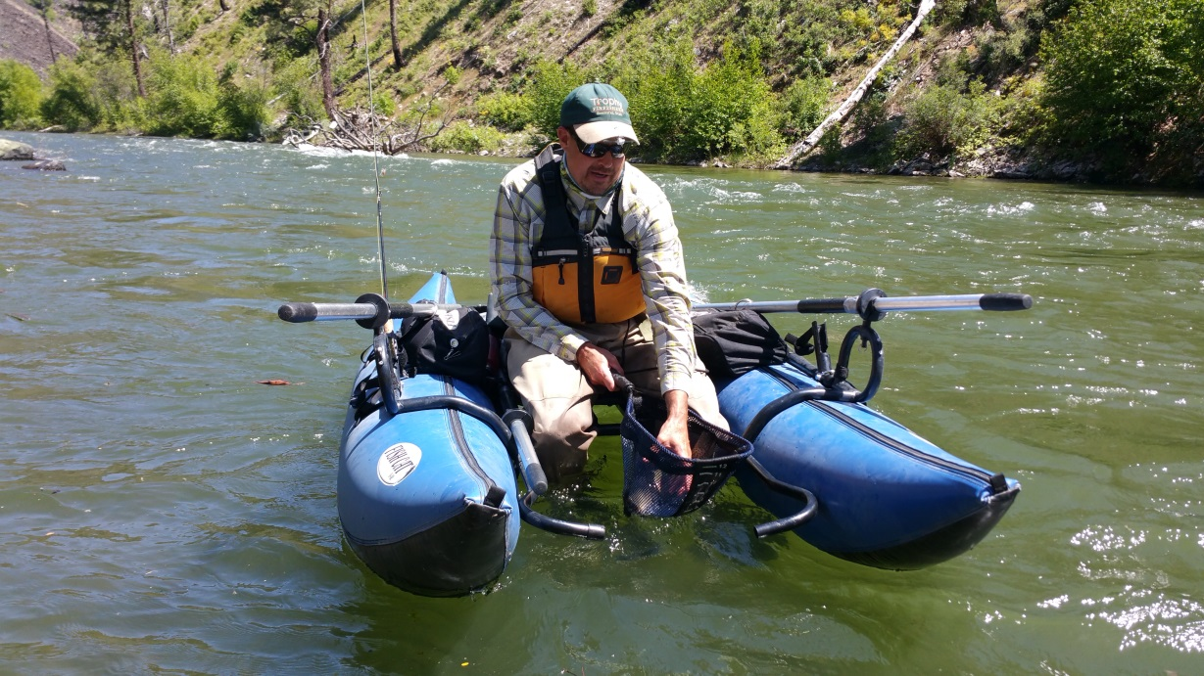

**What had started out as the perfect day was now our worst nightmare. I crawled upon the shore with waders full of water and immediately hit my knees. I am not a smart person but I know when I have been saved and it was very humbling. I began to pray and ask Heavenly Father what to do and if we would be okay. Before I could even finish what I was saying I was hit with a feeling I have never felt before. It was utter calmness and security. It was indescribable. I thought to myself there is no way everything will be okay so I asked again. “Please God, are we going to be okay?” Again I was hit with an overwhelming feeling that He was watching over us and would get us out of this situation.**

**Here I was in the middle of a canyon and had just watched my wounded friend disappear around a corner not knowing his fate. I remembered a conference talk from a while ago. Doubt your doubts before your doubt your faith. It was incomprehensible how we would get out of this situation but I was assured that we would. It was time to stop doubting my faith. I knew my prayer was answered. I started my hike up the canyon with a renewed faith towards a large cliff knowing that I was getting out of there and that Brad was going to do everything he could to get in a position and wait for me to get help.**

**As I neared the top the shale slide I knew I would have to begin cliff climbing. I found a spot on the cliff that appeared to be 60 to 80 feet high. As I started out on the ledge, my first grasp for a hand hold resulted in shale peeling away from the cliff. I knew this wasn’t going to work as the rock was very unstable. I proceeded backwards up the canyon following the cliff line until it lead me closer to the top and a section of cliff only 20 to 30 feet high. This area was stable and I was able to climb to the top.   
It was times like this I was thankful that my dad had taken me into the hills many times as a boy. I was taught a general sense of direction and what to do if ever lost in the woods. Although I didn’t really consider myself lost, I had never been above the canyon walls before and wasn’t exactly sure where I was. I did know that there was a road somewhere in the area and I needed to find it. Lucky for me I found the road within minutes and began jogging down river.**

**Although I was given strong reassurance things would be okay, my intellectual side still found urgency and I began to run down the road to the north. My emotions were running wild as I was trying to contemplate what exactly I needed to do. I prayed (while running) that a vehicle would be driving down the road and pull over to listen to me. What I didn’t realize until later is that I looked like I had just escaped a mental hospital. In order to make it up the mountain, I cut the boots out of my waders so I didn’t have the extra weight of the waders while climbing. Underneath my waders I was wearing long johns and basketball shorts with a long sleeve moisture wicking shirt. I then took my knife and slid it onto my wader belt and put it around my waist. I am sure anyone that saw me jogging down the street had to be thinking there is no way I am stopping for this crazy bald guy.**

**Within ten minutes I spotted dust rising on the horizon where the road disappeared. I knew at this time my prayers were answered again. I was able to stop the car and ask them for help. We were in an area where there is no cell coverage so communication was going to take a while. The driver of the vehicle promised that they would make it the 14 miles to Prairie and call emergency services. What a relief (at least I thought) it was to have finally found help.**

**At this point I knew Brad was still in the river somewhere so I continued to run up the road to a place where I could get a better look over the canyon. I knew he would be with the boat so it was my goal to find the boat. After I had made it about a mile up river I came to a place where the road was near the cliffs edge. I walked over to the cliff and looked down at the river. I was amazed as I saw both boats stuck in a back eddy. They were both upside down and so far away (the cliff wall seemed to be nearly 200 feet tall at this point) I could tell they were our boats but could not see a person. I began screaming for Brad to stay put and that help was on the way.**

**It was at this time I heard another vehicle coming up the road. In my haste to find help I neglected to ask the first car to please call our wives and let them know the situation. I also forgot to ask for water. You can imagine how climbing out of a canyon on a hot day will give a guy cotton mouth. As I flagged down the upcoming car I was beginning to understand what a freak I must look like. The car slowed as they got close and began to roll down the window. However, as I reached towards the car to use as a rest, the driver immediately rolled the window back up and left two inches for me to speak through. Can’t say I blame her. My friends do the same thing. I was able to let her know what was going on and I asked her to please call my wife when she had a chance. I then asked for water if she had any. What a blessing it was to find out she was on her way back from town and had purchased a case of bottled water. She welcomed me to some while she apologized it may be warm. She didn’t’ realize that I was thirsty enough to suck the sweat out of a skunks butt. Warm water was the last of my concerns.**

**She left on her way and assured me that she would be in touch with my wife as soon as she was able to get cell coverage. I went back to the canyon wall to continue to communicate with Brad. When I got back both boats had moved downstream. Brad’s was much further ahead of mine and was headed down another rapid chute. Mine appeared to be working across the river toward a back eddy and an area of land where it could be beached. I was sure Brad was swimming with it because it was moving in a way I thought could only be done if a person was pulling it. I started to holler again to let him know I was still there. Still there was no sign of life but I was hanging on to the hope that he was down there and that he could hear me.**

**After what felt like hours the search and rescue teams arrived. They were quick to ask questions and get apprised of the situation. I instructed them I was sure Brad was with the boat as it was his most likely survival tool and he knew I would be looking for it if I was able to break the confines of the canyon.**

**Growing up hunting big game for most of my life I was accustomed to using field glasses or binoculars in search for animals. Never could I have imagined that this skill set would come in handy when looking for a person. Binoculars come in many different styles and quality. The better the optics (lenses) the easier it is to study the field of view. I was sure the EMT folks would be equipped with top of the line equipment based solely on the amount of taxes I pay. I mean the money has to go somewhere right? This was not the case. Although I was extremely thankful they were there, the optics in use were not quite up to par. I only bring this up because I believe this was a key element in saving Brad.**

**In speaking with the EMT team, I was told there were a couple of options. One was to send a raft in from the same place we started our trip this morning. The other was to call life flight. I was told life flight will not come if we do not have a location on the subject. This made spotting brad at the bottom of the canyon even more important. We began frantically searching through the binoculars for a body below. To my relief the EMT said she had spotted Brad below a section of rapids on a sandy beach. I didn’t think much of it at the time but it was enough for them to call Life Flight and say “We have a visual. Please send a chopper!”**

**And so it was, the rescue was underway. A chopper would be taking off shortly. Mentally I was excited that this event was nearing an end. In my excitement I asked to use the binoculars to secure my own visual on Brad. However, I was unable to see him. I told the personnel I was with that I could not see him but was informed that he was on the beach below the rapids. Still I couldn’t see him. It also made no sense to me that a man with a broken leg would shoot the rapids in just a life jacket when there was a large smooth body of water in which he could swim to a safe area. I told them I thought it very unlikely that he would take the rapids in his condition. I said he has to be under the boat on the beach. We then began to glass again and realized that what they thought was him at the bottom of the rapid section was in fact nothing at all. Time was passing and I was beginning to doubt my faith again. It had been a few hours and I knew night would be approaching.**

**Knowing our remote location I realized the options presented were the best available. However, I knew that it would take hours for a boat to reach the point in the river where we were currently searching. Time was not our friend as I knew if Brad was alive he was not in a good situation. The last I saw him he was hanging on to a boat bouncing his broken leg down through rapids. I worried that he may pass out from the pain and sink into the water. I was also unaware of the extent of the damage to his leg. I couldn’t be sure he wasn’t bleeding out as he had his waders on when I last saw the wound.**

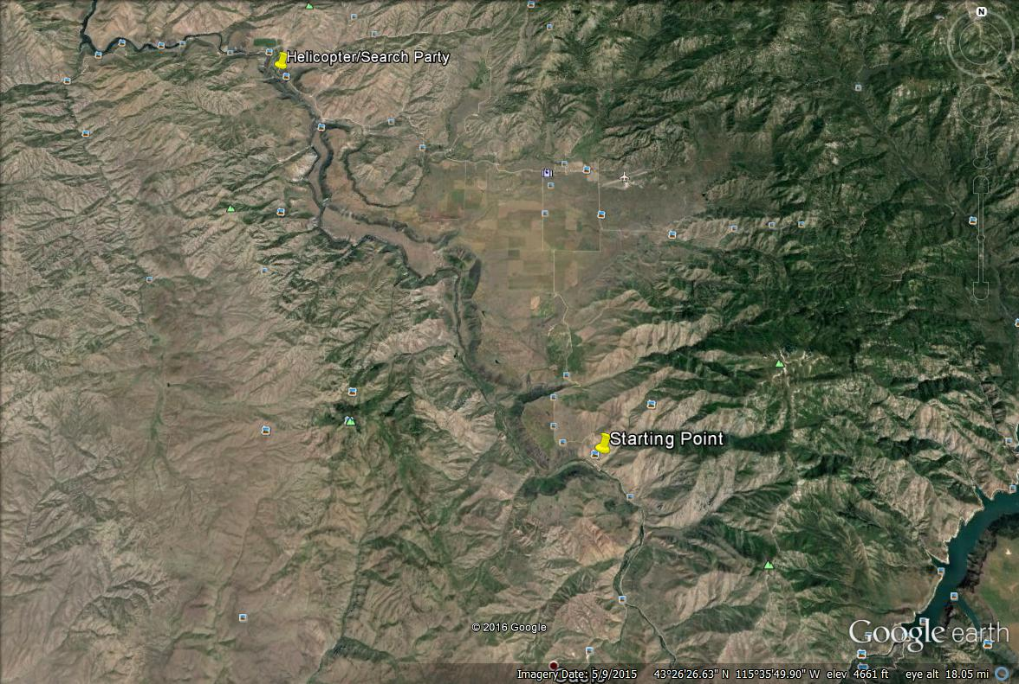

**One of my biggest fears was that he would go into shock. I voiced my concerns to the EMT person I was with. She gave me her name but I was in such a state I cannot remember it. Her and I had broken away from the group and were talking. Not being a medical minded person, I asked her how long we have if he has in fact gone into shock. She informed me that shock is the process of your body shutting down. While it is not something I wanted to hear it did provide me with motivation.**

**The chopper arrived and landed on the top of the cliff in a meadow. I was not allowed near the chopper but the crew was instructed that we didn’t have a location but that he was most likely near the pontoon at the bottom of the gorge. As luck would have it, there was just enough room to get a helicopter into the area near the boat. I could feel the tension building as the chopper lifted off in route to the bottom of the canyon. As the chopper got closer to the boat it appeared as though they were landing. I couldn’t imagine them landing if they didn’t see a body. Those around me could sense my emotions as I was verbally discussing all the options at 200 words per minute. “They wouldn’t land unless they saw a person right? He has to be under the boat. Will they drop a basket to him? Do they see him? Are you in contact with the pilot?” They probably wanted to put a muzzle in my mouth.**

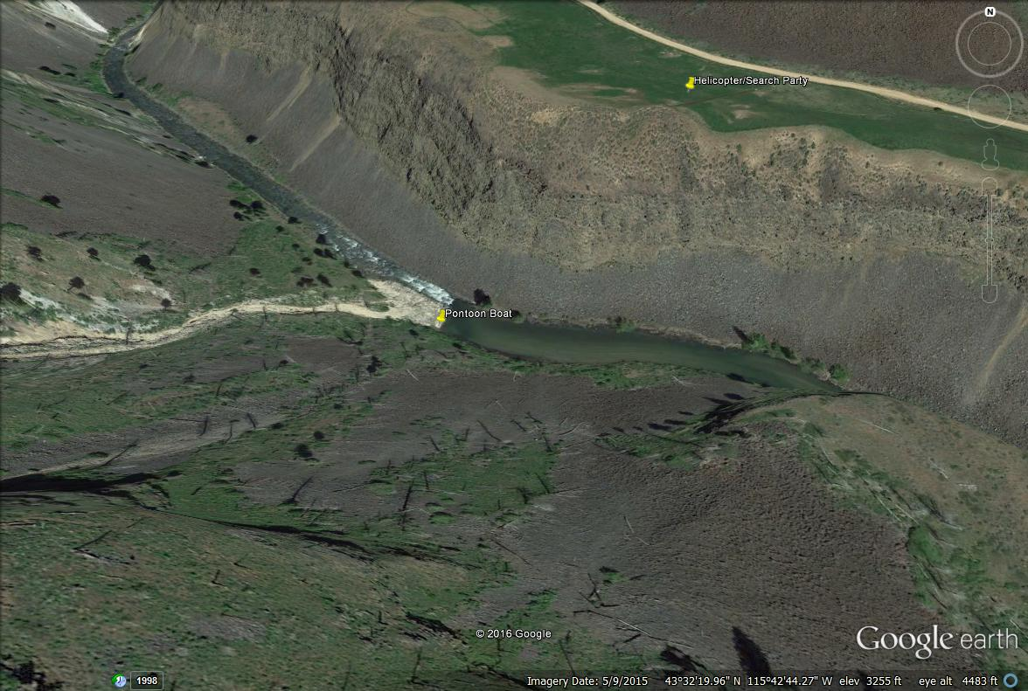

**The area near the pontoon was just wide enough to land. (see above) As the chopper neared the boat, the turbulence created from the rotary blades kicked the pontoon back out into the current. I was demoralized as I noticed Brad was not with the boat or on the beach. As the day was entering evening, I feared the worst. I could barely hold back the tears as I was beginning to realize my next phone call was going to be to Kimberly to tell her I let her husband die on my watch. It may not be the case but I was sensing a mission of recovery instead of a rescue mission. A very nice EMT man saw my anguish and said “take me to the place where you last saw Brad. We will take the binoculars and search for him.”**

**Meanwhile the chopper began headed down river toward the reservoir. I didn’t know if they were looking for a body or a person. I felt the weight of Brad’s family on my shoulders. Overwhelming guilt was setting in. I was not strong enough to bring back a husband, father, patriarch, friend, son, and provider like I had promised earlier in the canyon. How would I live with this? How could I ever look at his family again? All these emotions were going through my mind.**

**With binoculars in my hand, we went up river in search of Brad. It was my hope that he had made it to shore and was awaiting our help. With glassy eyes and shaky hands I began to glass the canyon where I had first spotted the overturned boats. I thought maybe he tried to hold them as long as he could but then let go in order to save himself. I looked over every rock in that area and under every bush. There was nothing!**

**I began praying internally as hard as I could. I needed to find him. Darkness would be on us soon and I was unsure of the protocols for search and rescue. Would they continue the search into the night or would they wait until morning? “He won’t make it through the night.” I kept babbling to myself. This has to happen now.**

**I began to scour the same side of the river I was on. I was looking approximately a quarter mile up river and slowly glassing back towards me. Nearly half way back to the point I was standing I saw a large black rock slide. About 10 yards up from the river I saw Brad sitting on the rocks. At this point my emotions got the best of me. I handed the binoculars to the EMT I was with and said “Please verify that is him. I hope I am not seeing things.”**

**The next thing I heard was him radioing the other EMT’s. “Send the chopper. We have a visual!!!” As the chopper approached my beaten and broken friend, I saw him raise his arms and wave. At this point I KNEW we would be okay.**

**He was in an area to sketchy for a chopper to land. However, they were able to drop him a warm blanket, food, water, and a radio to communicate with the EMT personnel. They instructed him that a boat with two of the most qualified personnel were launching at Danskin ramp with medical supplies. They would take him down river to a place where the chopper could pick him up and get him to the hospital.**

**What a day it was. Emotions ranged from excitement for our trip to the scariest thing I have ever faced. (and I have been face to face with an Alaskan grizzly bear) I learned so much in the hours that passed that day. I was reassured that God is in control. What he wants with Brad is beyond me but there is definitely something in store for him. I learned that even though we are weak in our mortal state that God loves us and understands us. He knows who we are and he knows our needs. He does not judge us for our past. He only wants us to understand our future. I left that rocky cliff side knowing that I had an interaction with Heavenly Father. There is no doubt. I learned the value of friendship. I have been thanked by the Chatlins numerous times for saving their husband and father. However, it feels like thanking a hammer for pounding a nail or a saw for cutting a tree. What I experienced will stick with me for a lifetime. I only hope that whoever reads this will understand that despite anything you have done God will always be there. We are his family. He will not leave us in the canyon of life. He will use his tools to rescue us and bring us back home. We only need to find a safe place on shore and let him help.**

